SENDING YOUR CHURCH WMO EMAILS SAMPLE EMAIL 4

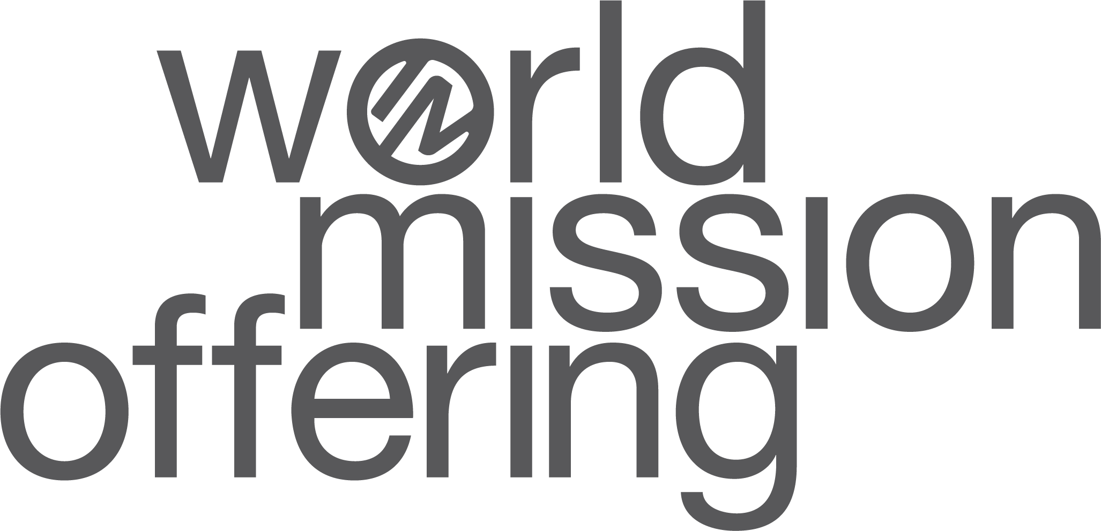

Hello!
As we’ve spent this month learning more about God’s work around the world, I hope you have been prayerfully considering the part God may be asking you to play.
If you are still wondering whether to participate, you might like to read Why Participate in the WMO? and hear from other churches who have seen how God has used their giving to be at work not only in other countries but also in their community.
How can you give to the World Mission Offering?
- Give your WMO gift to our church office. We then send these donations through our American Baptist Churches USA regional office. If you give by check, please write “WMO 2023” on the memo line.
- Send a check made payable to “International Ministries” and mail to International Ministries, 1003 W 9th Avenue, Ste A , King of Prussia, PA 19406.
- Give online at www.worldmissionoffering.org.

I pray that the time we’ve spent this month thinking about global mission can impact us as Christians throughout the year. Kingdom work happens all year long! Let’s dedicate our prayers and finances to take part in what God is doing around the world.

With blessings,
[church pastor or mission chair]

