SENDING YOUR CHURCH WMO EMAILS SAMPLE EMAIL 3

Hello!
As we continue our month dedicated to the World Mission Offering, will you take just a few minutes to watch another short video showing the impact our church can have when we partner financially with International Ministries’ global servants?
Our gifts to world mission make it possible for IM’s 120+ global servants to share the love of Jesus Christ while bringing help in difficult circumstances. In this video, you can meet Global Servant Faye Yarbrough, who is using her math and science background to tutor and mentor students in South Africa. The link is available here.
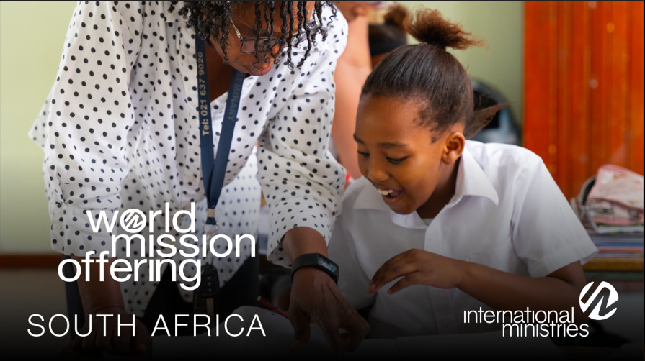
We can become partners in something God is doing that is bigger than our church. How might God call on us to take part in this kingdom work?

Together with you in mission,

[church pastor or mission chair]

