SENDING YOUR CHURCH WMO EMAILS SAMPLE EMAIL 2


Hello!
As part of our month dedicated to international mission, last week I asked you to watch a brief video from International Ministries’ Executive Director Sharon Koh.
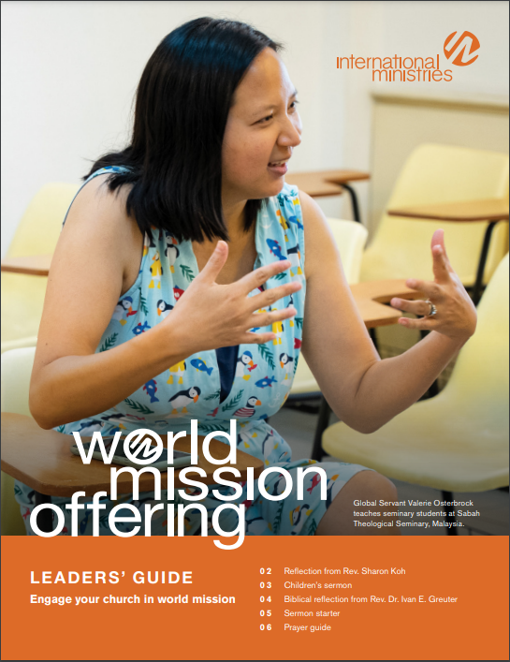
This week, I want to share with you the International Ministries (IM) Leaders’ Guide, which includes a month of short prayers written by IM global servants. You can download a copy here.
As you pray these prayers with IM global servants, you partner with them in sharing the gospel, in discipleship and education, in ministry to survivors of human trafficking, in peacemaking, and so much more.
Can your small group commit to pray a few of these prayers each week as you meet? Can your family pray one of these prayers each night at dinner?
May God use the people in our church to bless the work of these faithful servants around the globe.

Serving with you in mission,

[church pastor or mission chair]

