SENDING YOUR CHURCH WMO EMAILS SAMPLE EMAIL 1

Hello!
As you may know, in September and October our church dedicates time toward awareness, advocacy, and action for global mission as part of the World Mission Offering. We are able to participate in God’s work around the world in partnership with International Ministries (IM), a cross-cultural mission agency with a long heritage in the American Baptist mission movement and beyond.
This week, I want to give you the opportunity to see first hand the impact our church has when we partner financially and in prayer with IM’s global servants.
Through this link you can hear from IM’s Executive Director Sharon Koh about why the World Mission Offering matters and meet the global servants featured this year.
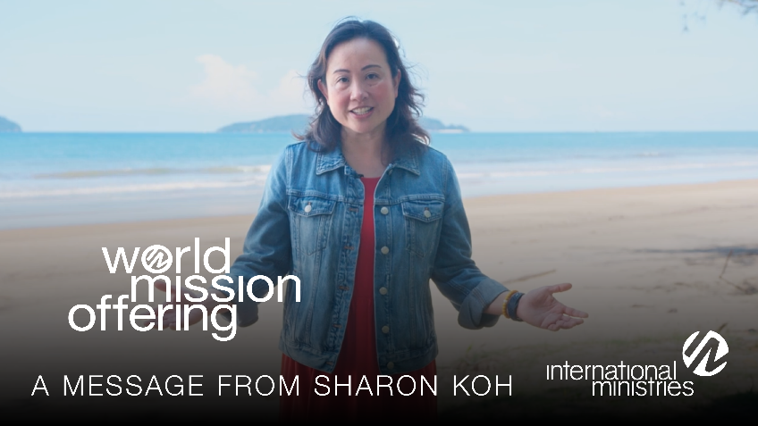
As you watch, I want to encourage you to consider prayerfully how God might be calling you, your family, and our church to participate in these kingdom ministries.

With blessings,
[church pastor or mission chair]

