SENDING YOUR CHURCH WMO EMAILS SAMPLE EMAIL 3

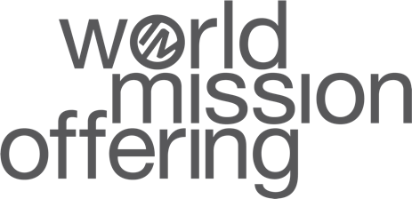
Hello!
As we continue our month dedicated to the World Mission Offering, will you take just a few minutes to watch another short video showing the impact our church can have when we partner financially with International Ministries? Our gifts to world mission make it possible for IM’s 120+ global servants to serve in 70+ countries around the world—sharing the love of Jesus Christ while bringing help in difficult circumstances.
In this video, you can see Rhonda Reed’s work to provide medical care to underserved communities in Bolivia. Learn how J.D. Reed and other IM global servants are making theological education accessible to church leaders in Iberoamerica. And meet Sarah Matos, who is just beginning her ministry as a global servant. The link is available here.
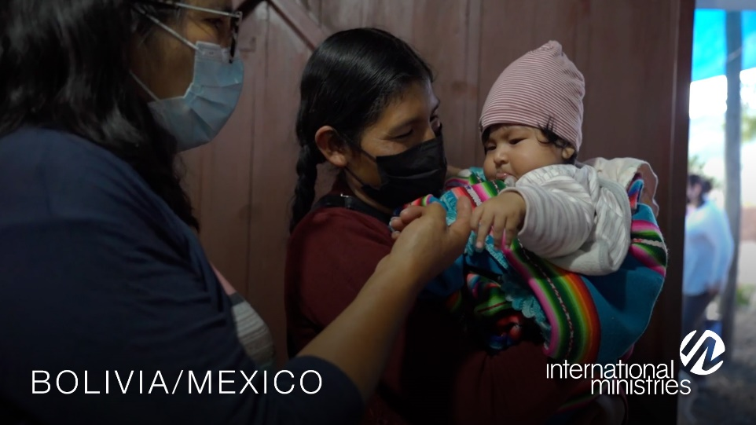
How might God call on our church to contribute to the World Mission Offering? We can become partners in something God is doing that is bigger than our church. God can use us to bring Christ’s kingdom to restore and impact places here on earth.

Together with you in mission,

[church pastor or mission chair]

